Dora Stratou Theater Consulting
Completed as part of the VCU School of Business & American College of Greece
International Consulting Program

Vasileios Bouronikos
Denajia Lowery
Marion Panagiotopoulou
Brandon Powell

July 1, 2016

Table of Contents

- Executive Summary……………………..……………………………………………….. 3
- Introduction………………………….………………………….………………………... 4
- Scope of Work/Methods…………………………………………………………………..4
- Findings...…………………………………………………...…………………………….6
  - Identifying the Target Market……………...……………………………………...6
    - Organizations & Dance Programs in the US
    - Dance Hotbeds in the US
B. The Social Media as a Promotional Tool..……………………………………..….9
C. Possible Media Partners………………………………………………………….11
- Conclusions……………………………………………………………………………... 13
- Recommendations………………………………………………………………………..14

- Executive Summary

This project aims to give Dora Stratou Theater and CID a small analysis of their target market, but also to identify universities and regions which are considered to be dance hotbeds in the United States. Furthermore, we hope to give insight on what media they can make use in order to promote their conference, thus developing a promotional strategy that they could employ for gaining exposure in the United States. Some recommendations are given based on research.
The project was started by mostly doing extensive online research. Due to the nature of our client and project, we did not really have to have access to academic databases, but when scientific research was needed in order to backup our suggestions, it was very easy to find online. However, we used the database provided by the International Dance Council. Finally, we made an online comparative analysis of other similar conferences, but we also investigated the current position of CID on Social Media. By synthesizing these data we came to our conclusions on what the organizers need.
After analyzing the CID’s current promotional strategies, but also their social media presence we concluded that CID has a lot of work to do yet. We found out that their social media pages are underutilized and that they are not regularly updated. During our analysis, we also looked into other relative conference’s websites and social media pages to see what they are doing to promote themselves and how effective they are in reaching to their audience. A trend among those was that they have an active and responsive presence in the social media. During our research about the use of social media, we found evidence suggesting that the use of social media as a promotional tool is a great way to reach to arts professionals. These arts professionals, including dance professionals, are huge fans of social media because it is a great way to showcase their work to a global scale. Further evidence suggest that arts organizations in US are daily posting stuff on the social media even multiple times.
A second conclusion was drawn after making a research online on the dance hotbeds in the United States. Virtually, a hotbed is considered a state or a region where there are prestigious arts/dance Universities or there are many dance organizations or dance schools who are very active. In broad terms, a good Arts/Dance University is considered an institution where the faculty is very active in research and from where many of the best dance professionals are graduating from. The conclusion that we reached was that if the client focused especially in those areas then it would be more likely to increase their number of attendees from the United States.
Finally, our research showed that there are a lot of media partners out there waiting to learn about opportunities related to arts, including dance. Those media partners will essentially help you promote your organization or event, in this case the World Congress on Dance Research, in a global scale and most importantly for free. This promotion can take all forms of communication formats like print, electronic or TV.
Our conclusions led us to five recommendations that we think that Dora Stratou Theater could strongly consider: 1) We deem necessary that Dora Stratou will need to use social media to increase U.S. attendance at future CID conferences in Athens, Greece, 2) Approach specialized media partners, 3) We suggest that the company must enlist in Help a Reporter (HARO) web site as a potential source for future researchers, 4) Communicate with the best dance Schools (list in findings) in the US in order to arrange visits and potential collaborations with, 5) Communicate with the conferees via email or through a questionnaire distributed the days of the conferences in order to get feedback about the conference.

II. Introduction

The aim of this report is to address the problem that Dora Stratou faces as the host organization of “World Congress on Dance Research” in Athens, Greece. Their concern is that the representation of the United States in this conference is limited, while they also maintain that there is room enough for great improvement in that aspect.
While we were doing our research, many questions were raised like: (a) What are the characteristics of the people attending to conferences like this one?, (b) From which part of the United States is most likely that they are coming from?, (c) What form of communication would be more effective in reaching that audience?, (d) Is Dora Stratou’s or CID’s communication Strategy effective enough?, (e) If not, what should they do to enhance that?, (f) Are there any media that Dora Stratou - CID could partner with and advertise their conference with no cost?
In order to provide the answers to these questions we needed to make a thorough online research. For example, we investigated the websites and social media pages of similar conferences, we made use of the CID database and finally the google scholar research tool to find related research to our project.

III. Scope of Work/Methodology

Our work as a consulting team started soon after our meeting with the client-company “Dora Stratou Theater” which works as a hosting organization of a world scientific conference on dance research under the name “World Congress on Dance Research”. In our first meeting at our client’s premises we met with Ms. Adamantia Angeli instead of the President Dr. Alkis Raptis, due to him being out of the country. During our meeting with Ms. Angeli, she informed us about the project that we need to undertake and tried to explain us the problem that they face. During that meeting we also met with Mr. Stergios Theocharidis, IT engineer of “Dora Stratou Theatre”, who guided us through the website and database of International Dance Council (CID) and explained to us how we can make use of it. However, because there was a discrepancy of what we were asked to perform during the meeting and the initial deal, we spent the next two days until our second meeting trying to figure out how we are going to proceed with the project. The reason that we wasted that valuable time was because we were asked from our client to make direct contact with prospected American attendants to the conference, which happens not to be a consulting project.

After our second meeting with the company, that this time was with Dr. Alkis Raptis, President of Dora Stratou and CID, we renegotiated our project in order to make it more of a consulting project rather than an executive one, which he seemed to understand it. In the previous days we had made a list of questions to ask him that we thought that could help us with the project, along with some questions that we had sent to their e-mails and had already received feedback on those. At the end of this meeting, we felt that our project aim was clearer now and we were about to start off with the initial deal for the project which was to modernize their communication methods and create a promotional strategy for the company in order to attract more American conferees.
From this meeting we concluded that we needed answers to the following questions: (a) What are the characteristics of the people attending to conferences like this one?, (b) From which part of the United States is most likely that they are coming from?, (c) What form of communication would be more effective in reaching that audience?, (d) Is Dora Stratou’s or CID’s communication Strategy effective enough?, (e) If not, what should they do to enhance that?, (f) Are there any media that Dora Stratou - CID could partner with and advertise their conference with no cost?.

In order to answer these questions, we gathered primary and secondary research information. For the primary research, we used the information that Ms. Angeli and Dr. Raptis gave to us during our meetings or from the e-mails that we received as feedback to our questions that we had sent. The secondary research included information from online research that was conducted on other similar conferences’ websites and social media pages in order to conclude what the other organizations are doing to promote themselves, we made use of the CID website and database to draw information on the conference but also to draw conclusions about their attending conferees and finally we used google scholar as a research tool to find research who can support our suggestion to them to use more the Social Media as an effective means of communication.

In order to answer the aforementioned questions we assigned different questions to different group members. For example, one group-member was responsible in making research about the demographics, psychographics and geographic location of past conferees, but also focusing on locations - dance hotbeds in the U.S - where it is more probable that the World Congress can attract conferees. Another group member was responsible to review the Social Media presence of our client, but also to see what other competing conferences are doing online to promote themselves. Based on that, we make recommendations to our client regarding what we think that they should improve in order to communicate their message more effectively to the respective American audience. In addition, another huge portion of our research was focused on identifying media partners that Dora Stratou and CID can utilize in order to promote their conference at no cost, as we were informed by our client that this is the only way that this can be done. Overall, all group members were engaged discussing ideas and trying to overcome the barriers that were constantly arising, thus making our work very much demanding and difficult.

III. Findings & Analysis

The target market is identified as professionals in the dance industry. We identified these markets by looking at organizations and universities in which we would find dance scholars, educators, and researchers. In order to reach this audience we plan to connect with dance research organizations as well as universities with outstanding dance programs.

Our team researched the most popular hotbeds for dance professionals in the United States. We realize that the International Dance Council may already be members of some of the organizations, but we want to express different ways to utilize that privilege. We also found some of the top dance programs at universities in the United States. After reviewing the universities’ websites we realized that these schools have a great reputation are well known for their performance in the field of dance. After observing the organizations and universities we geographically segmented the main locations that would be ideal for the International Dance Council to market towards.

Organizations & Dance Programs

The Congress on Research in Dance (CORD) is an international organization made up of dance scholars, educators, and artists. CORD publishes the Dance Research Journal three times a year through Cambridge University Press and it includes articles on a various dance topics. It is considered to be one of the most prestigious dance journals. These topics include dance history, theory, pedagogy, politics, science, and ethnography. This organization also holds annual conferences that bring together these artists, teachers, and scholars in the field of dance. The CORD conference provides seminars and workshops for people from all over the world to network and share ideas with each other. When one becomes a CORD member they have access to all of the announcements, publications, events, workshop participants, and research collaborators. Networking with other members of CORD and attending their conferences every year will be great exposure for the International Dance Council in the United States.

The Centers for Research in Dance Education at New York University and Temple University have a partnership with the National Dance Education Organization (NDEO). These centers were decided to provide research for dancers, researchers, artists, and educators who are known to be in diverse environments. NDEO at Temple University holds seminars about research methods and techniques. NDEO at New York University helps strengthen research application. Becoming a member at NDEO will provide tons of exposure including tables at conferences, public listings on the site, and access to their online forums.

Juilliard School

The Juilliard School in New York City offers students a four-year undergraduate program to be trained in the field of dance. Their faculty teaches a variety of topics from ballet to dance history. In the past, Juilliard alumni have won more than 100 Grammy Awards, 62 Tony Awards, and 24 Academy Awards.

Fordham University

The Alvin Ailey American Dance Theatre at Fordham University in the Bronx also has a great reputation. This school provides professional dance training and as well as education in liberal arts. The Ailey school’s alumni have pursued successful careers such as performing On Broadway and cruise ships and becoming choreographers and dance teachers.

Butler University

Butler University is located in Indianapolis, Indiana and their dance program focuses on ballet, jazz, and modern dance. Their program is known as one of the top 5 classical dance programs in the United States. They offer their students pre-professional opportunities so that they can get first hand experience in the industry.

Boston Conservatory

The Boston Conservatory provides students with technical training and academic courses. A few of the genres they train in include jazz, ballet, and modern dance. The school was named one of the Top 10 Dance Colleges in the U.S and the best contemporary dance program in the country (OnStage). The faculty and instructors are world class artists from major dance companies.

Oklahoma City University

Oklahoma City University’s School of American Dance and Arts Management does not focus solely on dance. They want their students to be trained in professionalism in the industry rather than just dance. Alumni have been known to be very successful after completing their dance program.
University of North Carolina
University of North Carolina School of the Arts has three dance programs that include classical ballet, contemporary dance, and preparatory dance. They also have an educational affiliate, the American Ballet Theatre for students to participate in. Students in the School of Dance develop technical skills, artistic creative, and stylistic versatility.
Virginia Commonwealth University
Virginia Commonwealth University’s Art school is ranked as the #1 public university art and design program in the U.S (U.S News & World Report). The dance program offers an undergraduate major and an undergraduate minor and international opportunities. They are also a member of the National Association of School of Dance.

Dance Hotbeds in the U.S.

The National Center for Arts Research (NCAR) provided us with an index of hotbeds of America’s arts and culture. The top five cities and metro divisions are as follows:

- Washington-Arlington-Alexandria, DC-VA-MD
- Nashville-Davidson-Murfreesboro-Franklin, TN
- New York-Jersey City-White Plains, NY-NJ
- Boston, MA
- San Francisco-Redwood City-South San Francisco, CA

We have conducted research on each location and how active they are in the dance industry. All of the locations have a high presence of dance professionals and will be ideal locations for the International Dance Council to market towards. for dance researchers that the International Dance Council should focus on marketing towards:

1. Dance Metro DC connects local dance organizations with each other. Their vision statement is “to cultivate a thriving dance community.” They provide events and resources for dance professionals so they can network. They focus on three priorities such as communications and networking, relational development over time, and creative research sharing. Dance Metro DC is a great organization that offers marketing opportunities for all dance professionals. There are also a number of universities with dance programs in DC. A few of those include Georgetown University, American University, and George Washington University. The faculty that take part in these dance programs are very skilled in their field and the faculty may find the International Dance Council interesting.
Founded over 20 years ago, the Richmond Ballet has definitely made built a good reputation for itself. In 1984 they became the first professional Ballet company in Virginia. The even offer a school that starts training kids at the age of 3. VCU has also partnered up with the Richmond Ballet and now offers a trainee program for current students.

2. Vanderbilt’s dance program promotes education and intellectual growth. Nashville Dance Center teaches a wide variety of dances and has aldo been named one of the best studios on Tennesse. The owner of the studio has been a professional dancer, teacher, and a choreographer. New Dialect is another dance training program located in Nashville. They focus on contemporary dance and their goal is to raise awareness.

3. New York City is one of the major hotbeds for dance professionals in the United States. As mentioned above, Alvin Ailey and Julliard are two of the most popular programs. You Should Be Dancing is another popular school that focuses on the social aspects of dance. There is a wide variety of types dance schools and genres.

4. Boston Dance Community Project has produced over 10 pieces for charity and
they have participated in events like NYC Dance Week and the Massachusetts Dance Festival. The city has a dance festival called Dance for World Community and it is a one week event. Some of the things they offer throughout the week include workshops, film screenings, and discussions.

5. San Francisco aldo has a large dance community. Dancers’ Group is an organization that offers programs and services to artists and professionals. They want to bring artists and organizations together in order to create a more unified community.

The county of Los Angeles has over 100 nonprofit dance companies and a number of unincorporated dancers. The Dance Resource Center of LA keeps the dance community informed about events and and provides resources. The Los Angeles Ballet is the city's only professional classical ballet company. They produce four performances a year that attracts a total audience of 30,000. Their press includes Los Angeles Times and Huffington Post. There are also schools with dance programs in Los Angeles such as The International Dance Academy Hollywood and University of California Los Angeles.

By starting to focus on these major dance communities in the United States and marketing towards them, more dance professionals will be aware of the the International Dance Council and will be interested in participating in the annual conferences.

Social Media

Advertising via social media has a huge impact on the presentation of companies. According to Statistica, 70% of the U.S population uses at least one social networking site. When you surf the web advertisements are everywhere. On Facebook, Youtube, Twitter, etc. In more recent years art professionals have used social media as a networking and promotional tool. Large art organizations have created a solid visual representation of their brands on social media platforms. This has also enabled them to engage with their current followers and promote to followers (Imperial Society of Teachers of Dancing).
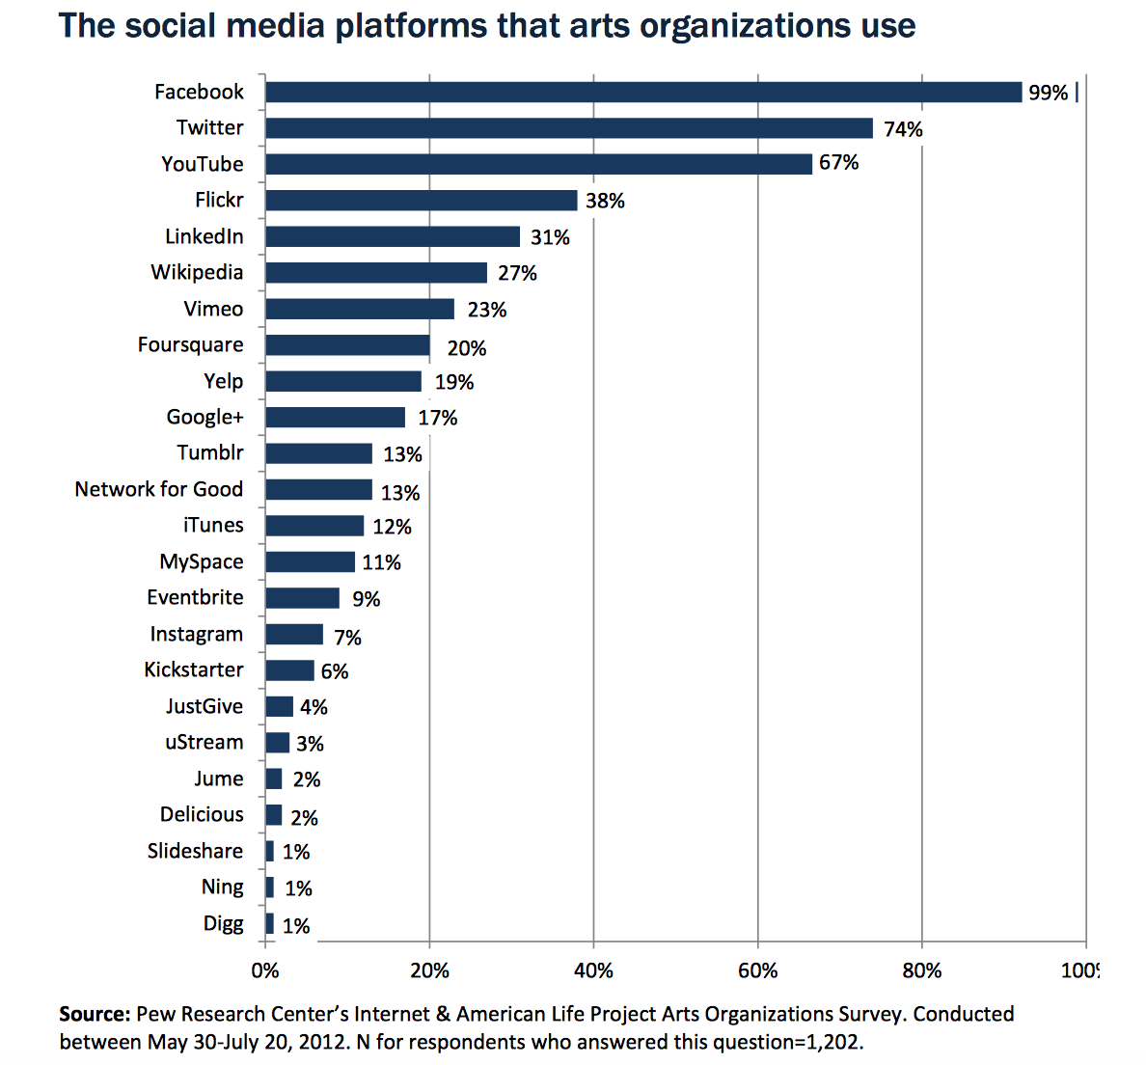
Seen above is a representation of what social media platforms are most commonly used by art organizations in the United States. Based on this chart it can be noticed that the largest majority use Facebook, Twitter, and Youtube. Pew Research found that 56% of art organizations in the United States maintain four to nine social media sites. These sites can be used to promote upcoming events and create awareness of the organization.

Dora Stratou currently uses Facebook as their main form of advertisement for the International Dance Conference in Athens. This conference currently does not have a strong social media presence. The current facebook account appears underutilized because the post are minimal in information and lack engagement with CID members. Also the videos and pictures shared on the current Facebook page do not showcase any past conferences which hinders the events credibility.

On the other hand other similar organizations such as the International Dance Organization (IDO) have extensively used social media to promote themselves in the international dance community. Their current facebook has 13,682 likes and are able to engage members through daily post. They use their Facebook account as a promotional tool for international conferences and post relevant information after these events to attract members to future conferences.

Through a social media focused campaign the CID conference in Athens will gain more exposure in the United States. In the 2012 Pew Research survey, 50% of art professionals in the U.S. strongly agreed that internet “has increased engagement in the arts by providing a public platform through which more people can share their work”. Due to social media playing a large role in the art community a strong online presence can be utilized as a promotional tool that enables researches to have their work broadcasted on a global scale. In order to maintain a strong social media presence it is important to keep the page relevant by posting consistently through the year to promote membership engagement. Also the Pew Research Center found that 45% of art organizations post to social media daily and another 25% stated that they post to social media account multiple times a day.

Media Partners

Undoubtedly nowadays the most common way to find out about something, research and learn about the news is through the internet. E-magazines,e-journals and news websites are replacing the traditional methods of getting informed about literally any subject (newspapers’ and printed circulation dropped 3%, and internet usage increased 5% over the last year). More specifically the past throughout the past few years there has been an overall dramatic increase of 37% of people relying on internet for their daily dose of news whereas television and printed newspapers demonstrated a decrease of 15% and 17% respectively.

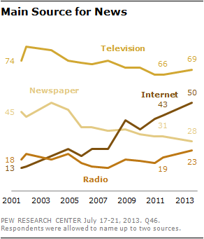
(http://www.pewresearch.org/)

Even famous and established newspapers make efforts to strengthen their online presence, in order not to fall behind in this trend. Usually the online forms include extra articles and features since space is not an issue when we talk about the online platform. In additions, the articles or videos featured in the web pages tend to get extra exposure or even become viral thanks to the mass and extensive use of social media. Furthermore, just like traditional newspapers, e-substitutes show to have a regular and committed audience as well. Moreover, the American Press Institution highlights the fact that the news that people are exposed to via an electronic news format (magazines, journals websites, etc) are the ones considered the most reliable.In the contrary social media and word of mouth fail to convince in depth that can be trusted, so they rarely succeed in convincing people to act upon them (example: join a group or an organization, participate in an event etc). The diagram that follows showcases exactly this tendency.
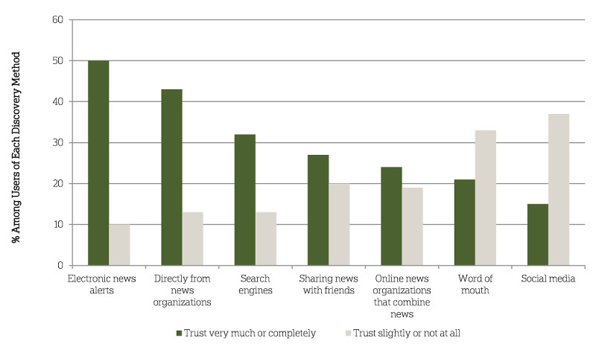
(http://www.journalism.org/)

Being a part of electronic news can be quite challenging sometimes for companies that are interested to be included in and be benefited from this growing trend.

Problems (according to Forbes Magazine) that often arise are :
- How can online press be attracted to a specific company ?
- Which publications should be approached?
- How can the company be advertised for free?

A very effective way that we believe also matches the characteristics of the company is enlisting the company as an expertise source. Thanks to the research that is being presenting in the World Conferences hosted by Dora Stratou, there is a lot of material available for journalists, researchers and writers to use in their future work. There are several websites and services that connect journalists with sources. Help A Reporter (HARO) is one of the most well known and popular resources, it is mostly used in the US and does not require any fees to be paid. If the interested party is searching for something that can be linked to the work of the company’s inventory, Dora Stratou can contact itself the journalist. It is an easy and effective way to get quoted and be featured in an article or project that is addressed (statistically the majority of the times) to the adequate target group. Other services that claim to connect sources with journalists worldwide includeProfNet from PR Newswire, Experts.com, and Muck Rack.

The most direct and forward way to get an online news presence is for the appropriate publications to be convinced to cover an event or make a spread about the company’s distribution to the field etc. Essentially the need of discovering the right publications and journalists is born. As a result of our research we noticed that the online magazines suitable for promoting and raising awareness about Dora Stratou and The CID World Conferences would be:
- Dance Magazine (http://dancemagazine.com/)
- Dance Teacher Magazine (http://www.dance-teacher.com )
- Dance for you Magazine (http://www.danceforyou-magazine.com/ )
- Dance Informa Magazine (http://www.danceinforma.com/)
- Dance Research Journal - published by the CORD- (http://www.cordance.org/danceresearchjournal)
- Dance Advantage (blog)
- Art Intercepts (blog)
- The Dance Journal (blog)

Furthermore it is quite common for the majority of the publications to not ask for compensation for writing a piece for a specific story, company or person. The majority of the writers prefer to focus on a credible, informative or intriguing story story that will interest their audience than be paid for a mediocre one. Pitching a story to them is an important factor that must always be taken under consideration. If the company aims for a long lasting collaboration, it is vital to establish and nourish a relationship between the company and the writer.

An alternative medium that could be approached and enable the spread of knowledge about the World Conferences could be television. There are specific network channels whose main theme is dance, or art in general. They extensively cover performances, concerts and highly prestigious events. Since these channels in their majority are featured in cable television only people that are really interested subscribe to them. In this way the company will be able to ‘advertise’ its work again in a very adequate target group. Such television channels are : the Dance Channel and Mezzo.

Dora Stratou’s World Conference is essentially a place where researchers gather in order to publish, present and showcase their work. Each publisher’s wish and goal is seeing his/her work becoming established, read and further studied by as many people as possible. In other words they care about publicity, exposure and media coverage (always talking about the selected target group). Media partners can assist in transforming the Conference’s image to a one similar to a World Summit’s one. By ensuring that the conferees’ work get the necessary exposure we estimate that there will be a definite rise of the interest levels.

IV. Conclusions

According to our research Dora Stratou has a relatively poor digital presence in terms of social media and media partners. In order to gain fame the company mainly relies on the word of mouth. From this fact arises a difficulty to contact and interact with people that may be interested in the company and its activities but are located in the other side of the Atlantic. In order to maximize the effectiveness of the developing new approaching methods we found that at least in the beginning the company should focus on connecting with US dance hubs. Our findings showcased that Washington-Arlington-Alexandria, Nashville-Davidson=Murfreesboro-Franklin, New York-Jersey City-White Plains ,Boston,San Francisco-Redwood City-South San Francisco, are the best places for the company to start its attempt. In addition, the best place to reach dance academics, which is a demographic group that really interests the company, is through a collaboration with their universities. Based on official rankings the best schools that demonstrate the best programs and research activity are : the Juilliard School, the Fordham University, Butler University, Boston Conservatory, Oklahoma City University and Virginia Commonwealth University. Moreover, we discovered that nowadays art organizations use extensively social media (Facebook has the lead) to promote their work and engage with their audience. Dora Stratou unfortunately has not yet capitalize on the benefits that these means can have to it’s reputation. Furthermore, as the audience of online news grows as well as their reliability we underline the importance of interacting with media partners. We researched and provided a very detailed list of e-magazines, journals, blogs and TV channels that could serve as a decent medium to communicate with the desirable audience. Last but not least we discovered another way to not only serve our objective but also promote the research presented to the International Conferences, which is enlisting the company as an official source for researchers and writers future work.

V. Recommendations

- We deem necessary that Dora Stratou will need to use social media to increase U.S. attendance at future CID conferences in Athens, Greece. Multiple social media platforms will need to be utilized to effectively promote the significance of this specific conference. The social media sites needed to effectively promote this conference are Facebook, Linkedin, Youtube, Twitter, and Instagram. Posting videos and pictures from past conferences on these social media pages will also increase the credibility of the conference. Also social media accounts will need to keep members updated throughout the year with relevant news and information about the dance industry. These pages should be used as a discussion forum to engage current and prospective members as well. Dora Stratou will need to designate an employee to focus on maintaining relevant social media accounts.

- Approach specialized media partners. By utilizing the importance and the prestige of the World Conferences and Dora Stratou’s Theatre partners whose main point of interest is dance, could be easily persuaded to write a piece about the company for free. Many non profit organizations (with TED as the brightest example) reach out to (social) media partners to advertise their work. So in order to implement this measure an employee should focus in sending emails, start and maintain the correspondence with potential journalists, writers, bloggers or even network executives. Some suggested publications and means of obtaining the necessary exposure are :
a) Dance Magazine (http://dancemagazine.com/)
b)Dance Teacher Magazine (http://www.dance-teacher.com )
c)Dance for you Magazine (http://www.danceforyou-magazine.com/ )
d)Dance Informa Magazine (http://www.danceinforma.com/)
e)Dance Research Journal - published by the CORD- (http://www.cordance.org/danceresearchjournal)
f)Dance Advantage (blog)
g)Art Intercepts (blog)
h)The Dance Journal (blog)
i)Dance Channel
j) Mezzo Channel

- Due to the extensive research and the big volume of material that Dora Stratou has in its inventory, we suggest that the company must enlist in Help a Reporter (HARO) web site as a potential source for future researchers.

- Communicate with the best dance Schools (list in findings) in the US in order to arrange visits and potential collaborations with the best dance academics the nation has to offer

- Communicate with the conferees via email or through a questionnaire distributed the days of the conferences in order to get feedback on how they were informed about the event and in which way they would rather be contacted and informed about future activities. In addition questions like what was the participants’ favorite part, and what would they like to see in an upcoming event.

Works Cited

B Dancewear. Web. 30 June 2016. <http://www.bdancewear.com/>.
"Boston Community Dance Project (BCDP)." SKooJ CorEO. 20 June 2012. Web. 30 June 2016. <https://skoojcore-o.com/bcdp/>.
"Centers for Research in Dance Education." NDEO Advancing Dance Education of the Arts. Web. 30 June 2016. <http://www.ndeo.org/content.aspx?page_id=22&club_id=893257&module_id=53173>.
The Congress on Research in Dance. Web. 30 June 2016. <http://www.cordance.org/>.
"IDO - International Dance Organization." IDO - International Dance Organization. Web. 30 June 2016. <https://www.ido-dance.com/ceis/webHomeIdo.do>.
IDO-International Dance Organization. Web. 30 June 2016. <https://www.facebook.com/IDO.International.Dance.Organization>.
International Dance Council. Web. 30 June 2016. <http://www.cid-portal.org/site/index.php>.
Meller, Georgina. "Social Media: The New Spotlight for Dancers." ISTD. Web. 30 June 2016. <http://www.istd.org/membership/membership-resources/social-media-the-new-spotlight-for-dancers/>.
"Page D'accueil | Mezzo.tv." Page D'accueil | Mezzo.tv. Web. 30 June 2016. <http://www.mezzo.tv/>.
Steimle, Josh. "How To Get Free Press For Your Business." Forbes. Forbes Magazine, 5 Feb. 2014. Web. 30 June 2016. <http://www.forbes.com/sites/joshsteimle/2014/02/05/how-to-get-free-press-for-your-business/#44eae74a4888>.
Summer, Jackson. "10 Best For Dance Performance In the US." ZoomTens. 09 July 2014. Web. 30 June 2016. <http://zoomtens.com/check-out-the-10-best-colleges-for-dance-performance-in-the-us/>.
Thompson, Krisitin. "Arts Organizations and Digital Technologies." Living with Geographic Information Technologies DIGITAL PLACES. Pew Internet. Pew Research Center, 4 Jan. 2013. Web. 30 June 2016. <http://www.pewinternet.org/files/old-media/Files/Reports/2013/PIP_ArtsandTechnology_PDF.pdf>.

