Dance in Ancient Greece.
A Virtual Visit in the Archeological Museum of Athens

s1640
Four men dancing led by a musician (forminx player)
Painting, vase
-750 Approximate date
9 cm
Greece, Athens, National Archaeological Museum, 14477
Vase found in Dipylon, Attica
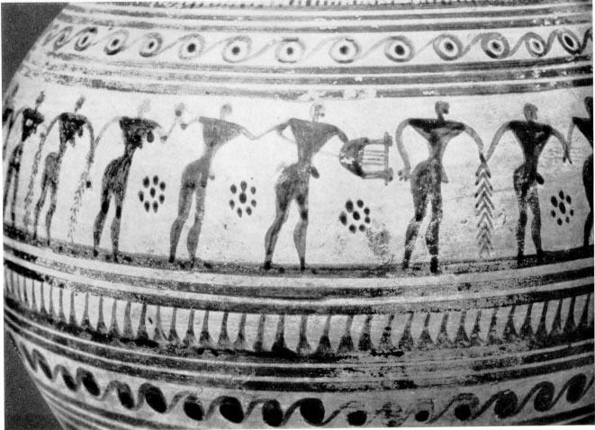

s4129
Attic Geometric oenochoe vase bearing incision mentioning dance
Painting, clay vase
-735 (B.C. approximately)
23 cm height
Greece, Athens, National Archaeological Museum, 192
The inscription says: ""Which now of all the dancers dances most charmingly, to him this…". The vase was the prize for a dancer at an event. This is the earliest known inscription in Greek language.
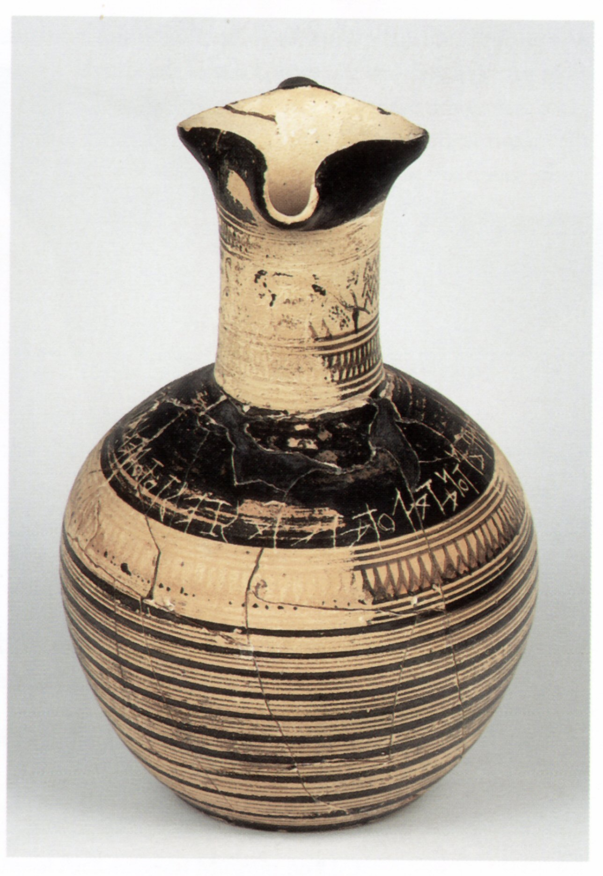

s4127
Men with raised arms in a line dance
Painting, clay vase
-720 (B.C. approximately)
29 cm height
Greece, Athens, National Archaeological Museum, 234
Dated 750-690 BC. Two of the figures hold branches. Between them are two lyres and a scorpion. Found in a sanctuary of Apollo at Amyklai, Sparta.
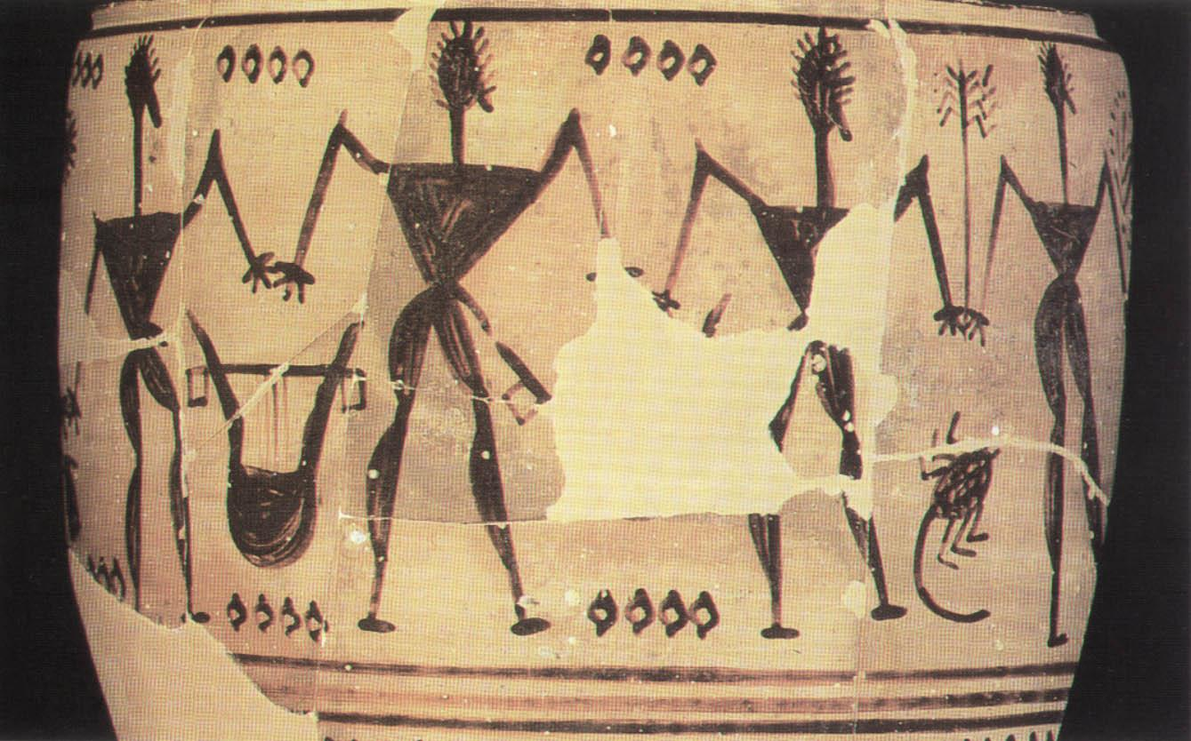

s4130
Four men with swords hanging from belts and nine women dance to the music of musician playing the phorminx
Painting, clay vase
-715 (B.C. approximately)
6.5 x 16 cm diam.
Greece, Athens, National Archaeological Museum, 874
There is also a lyre-player and two men with swords and two men with chelys, an earlier type of lyre. Four women appear to be watching the dance.
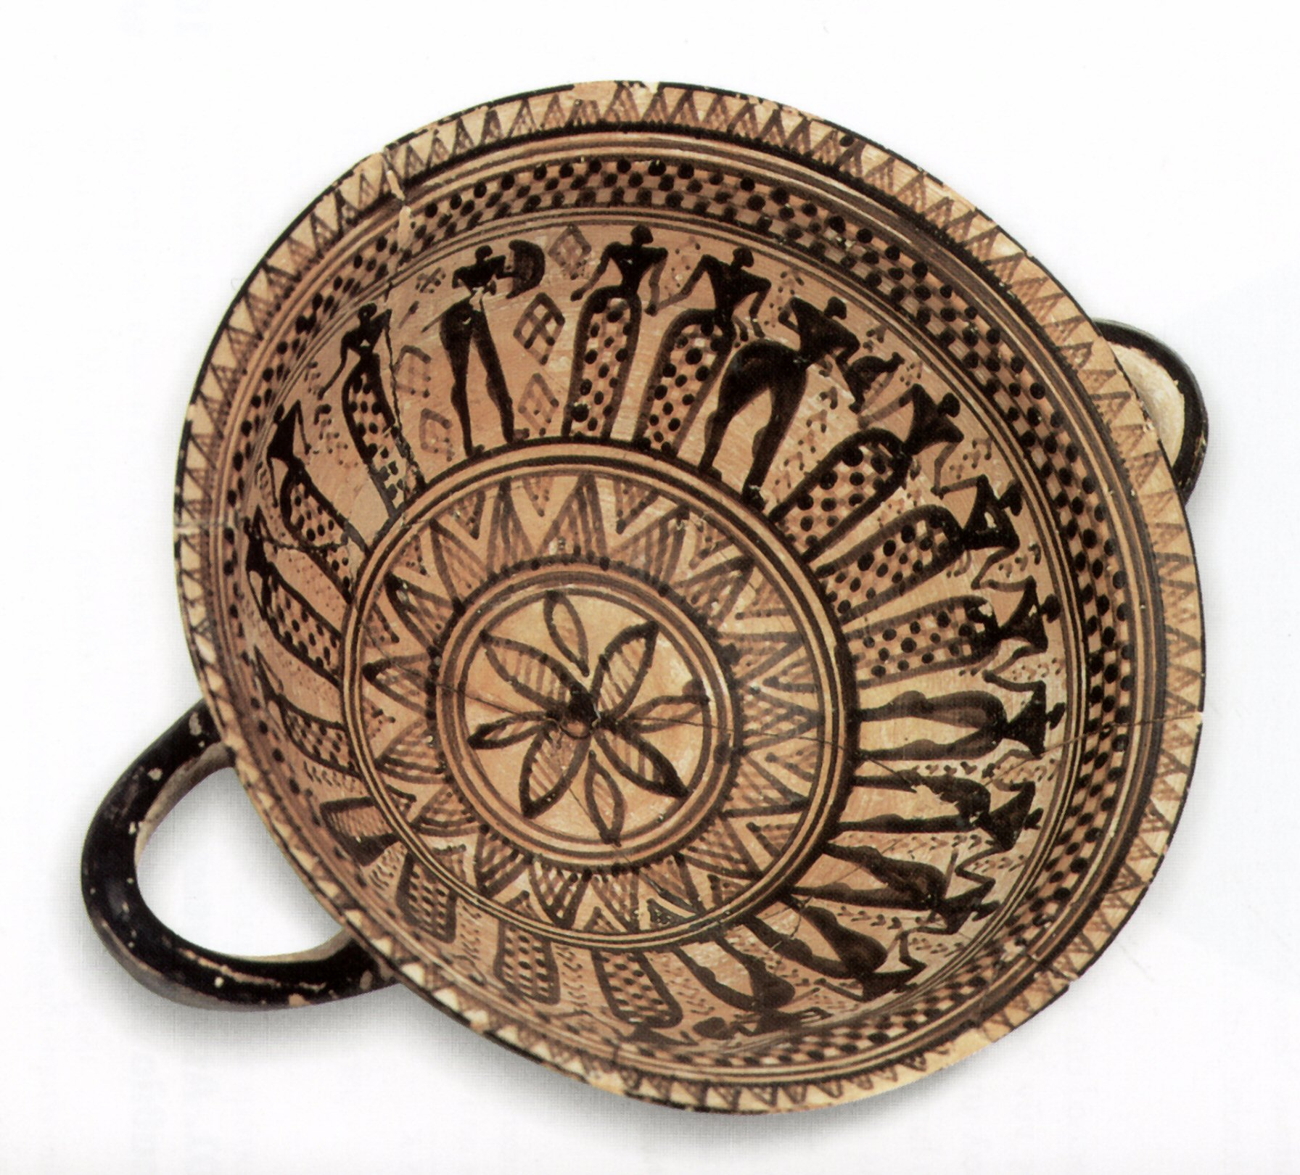

s4143
Five Maenads dancing in line between two Sphinxes
Painting, clay vase
-500 (B.C. approximately)
12.1 x 23.3 cm diam
Greece, Athens, National Archaeological Museum, 360
The daners are clad in chitons and have ivy wreaths in their hair, which identifies them as Maenads, probably taking part in the cult of Dionysos with mystic rites and ecstatic dance
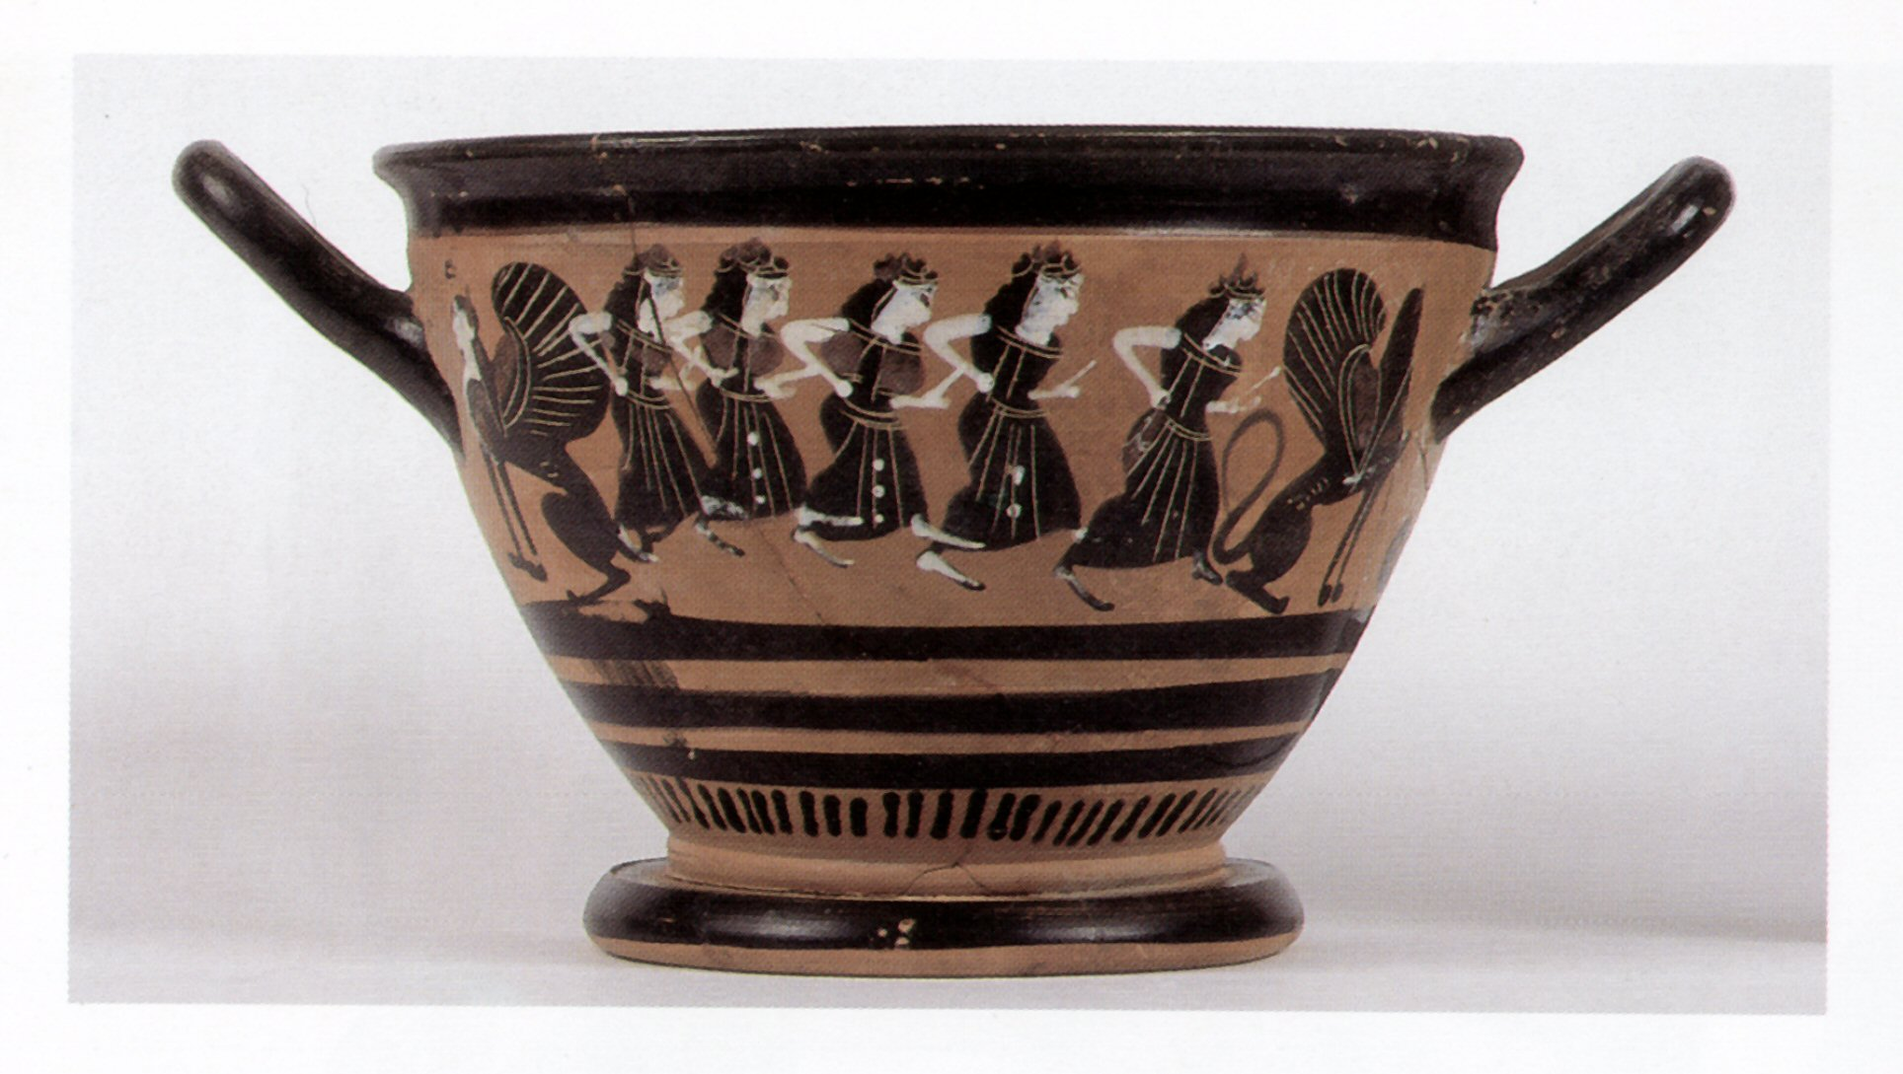
s1899
Women dancers
Painting on a vase
22. -490 (B.C. approximately)
Greece, Athens, National Archeological Museum?
Found in tomb 1099 of the Ceramic Cemetery of Athens, during excavations for the metro subway
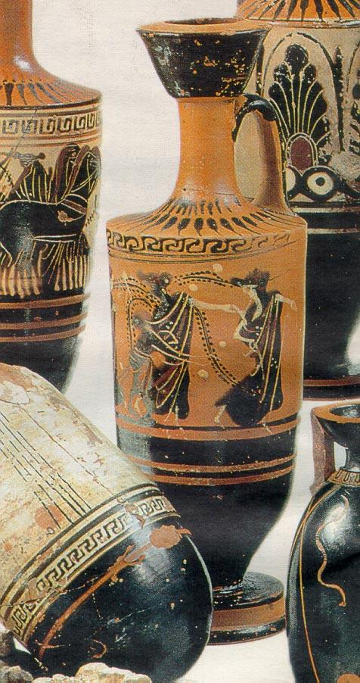

s4142
The Emporion Painter
Two Pyrrhiche armed dancers and aulos-player. Attic black-figure Alabastron vase
Painting, clay vase
-470 (B.C. approximately)
15 cm height
Greece, Athens, National Archaeological Museum, 512
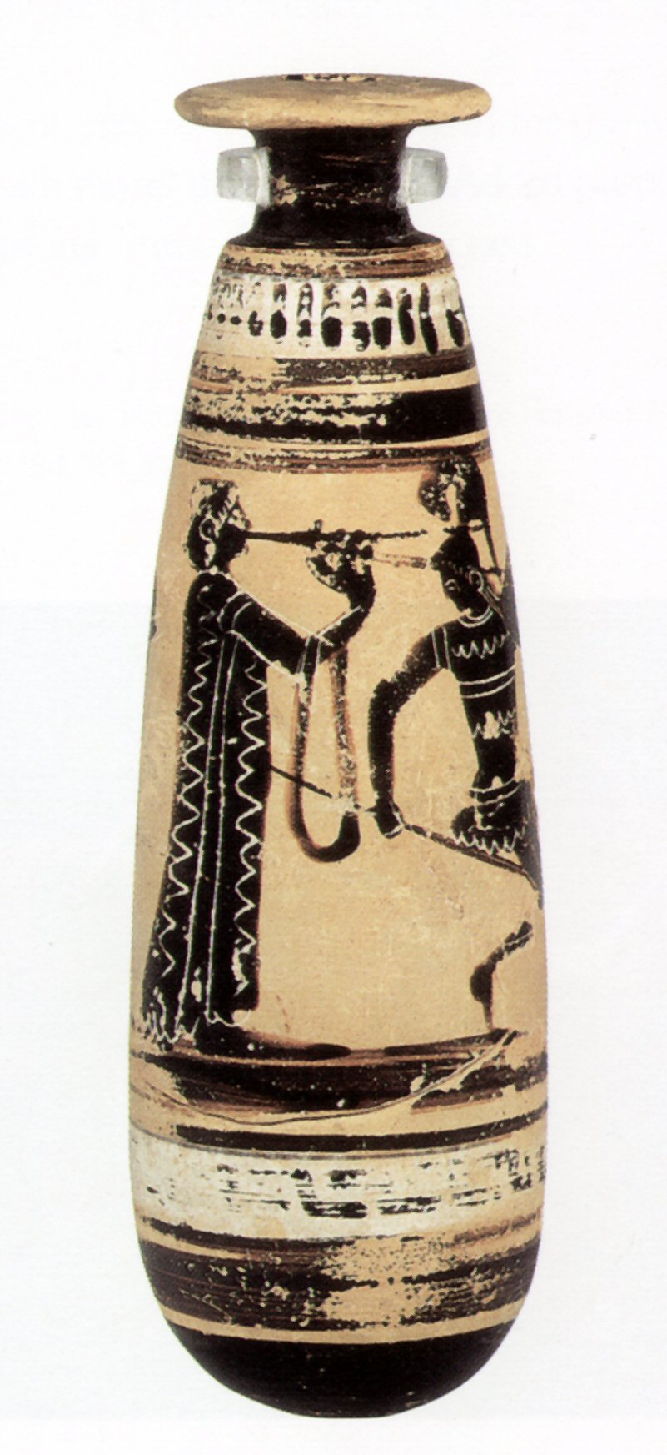

p0814
Satyr and maenad
Painting, vase, black-figure
-400 (B.C. approximately)
Greece, Athens, National Archeological Museum
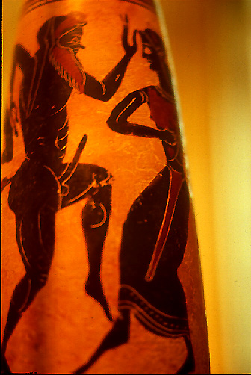
s4133
Girl on a table performs the Oklasma or Persian dance. Boeotian red-figure Kalyx Krater vase
Painting, clay vase
-385 (B.C. approximately)
25 cm height
Greece, Athens, National Archaeological Museum, 12683
The dancer wears a knitted oriental costume with sleeves and trousers. Two female musicians play the aulos and the tambourine
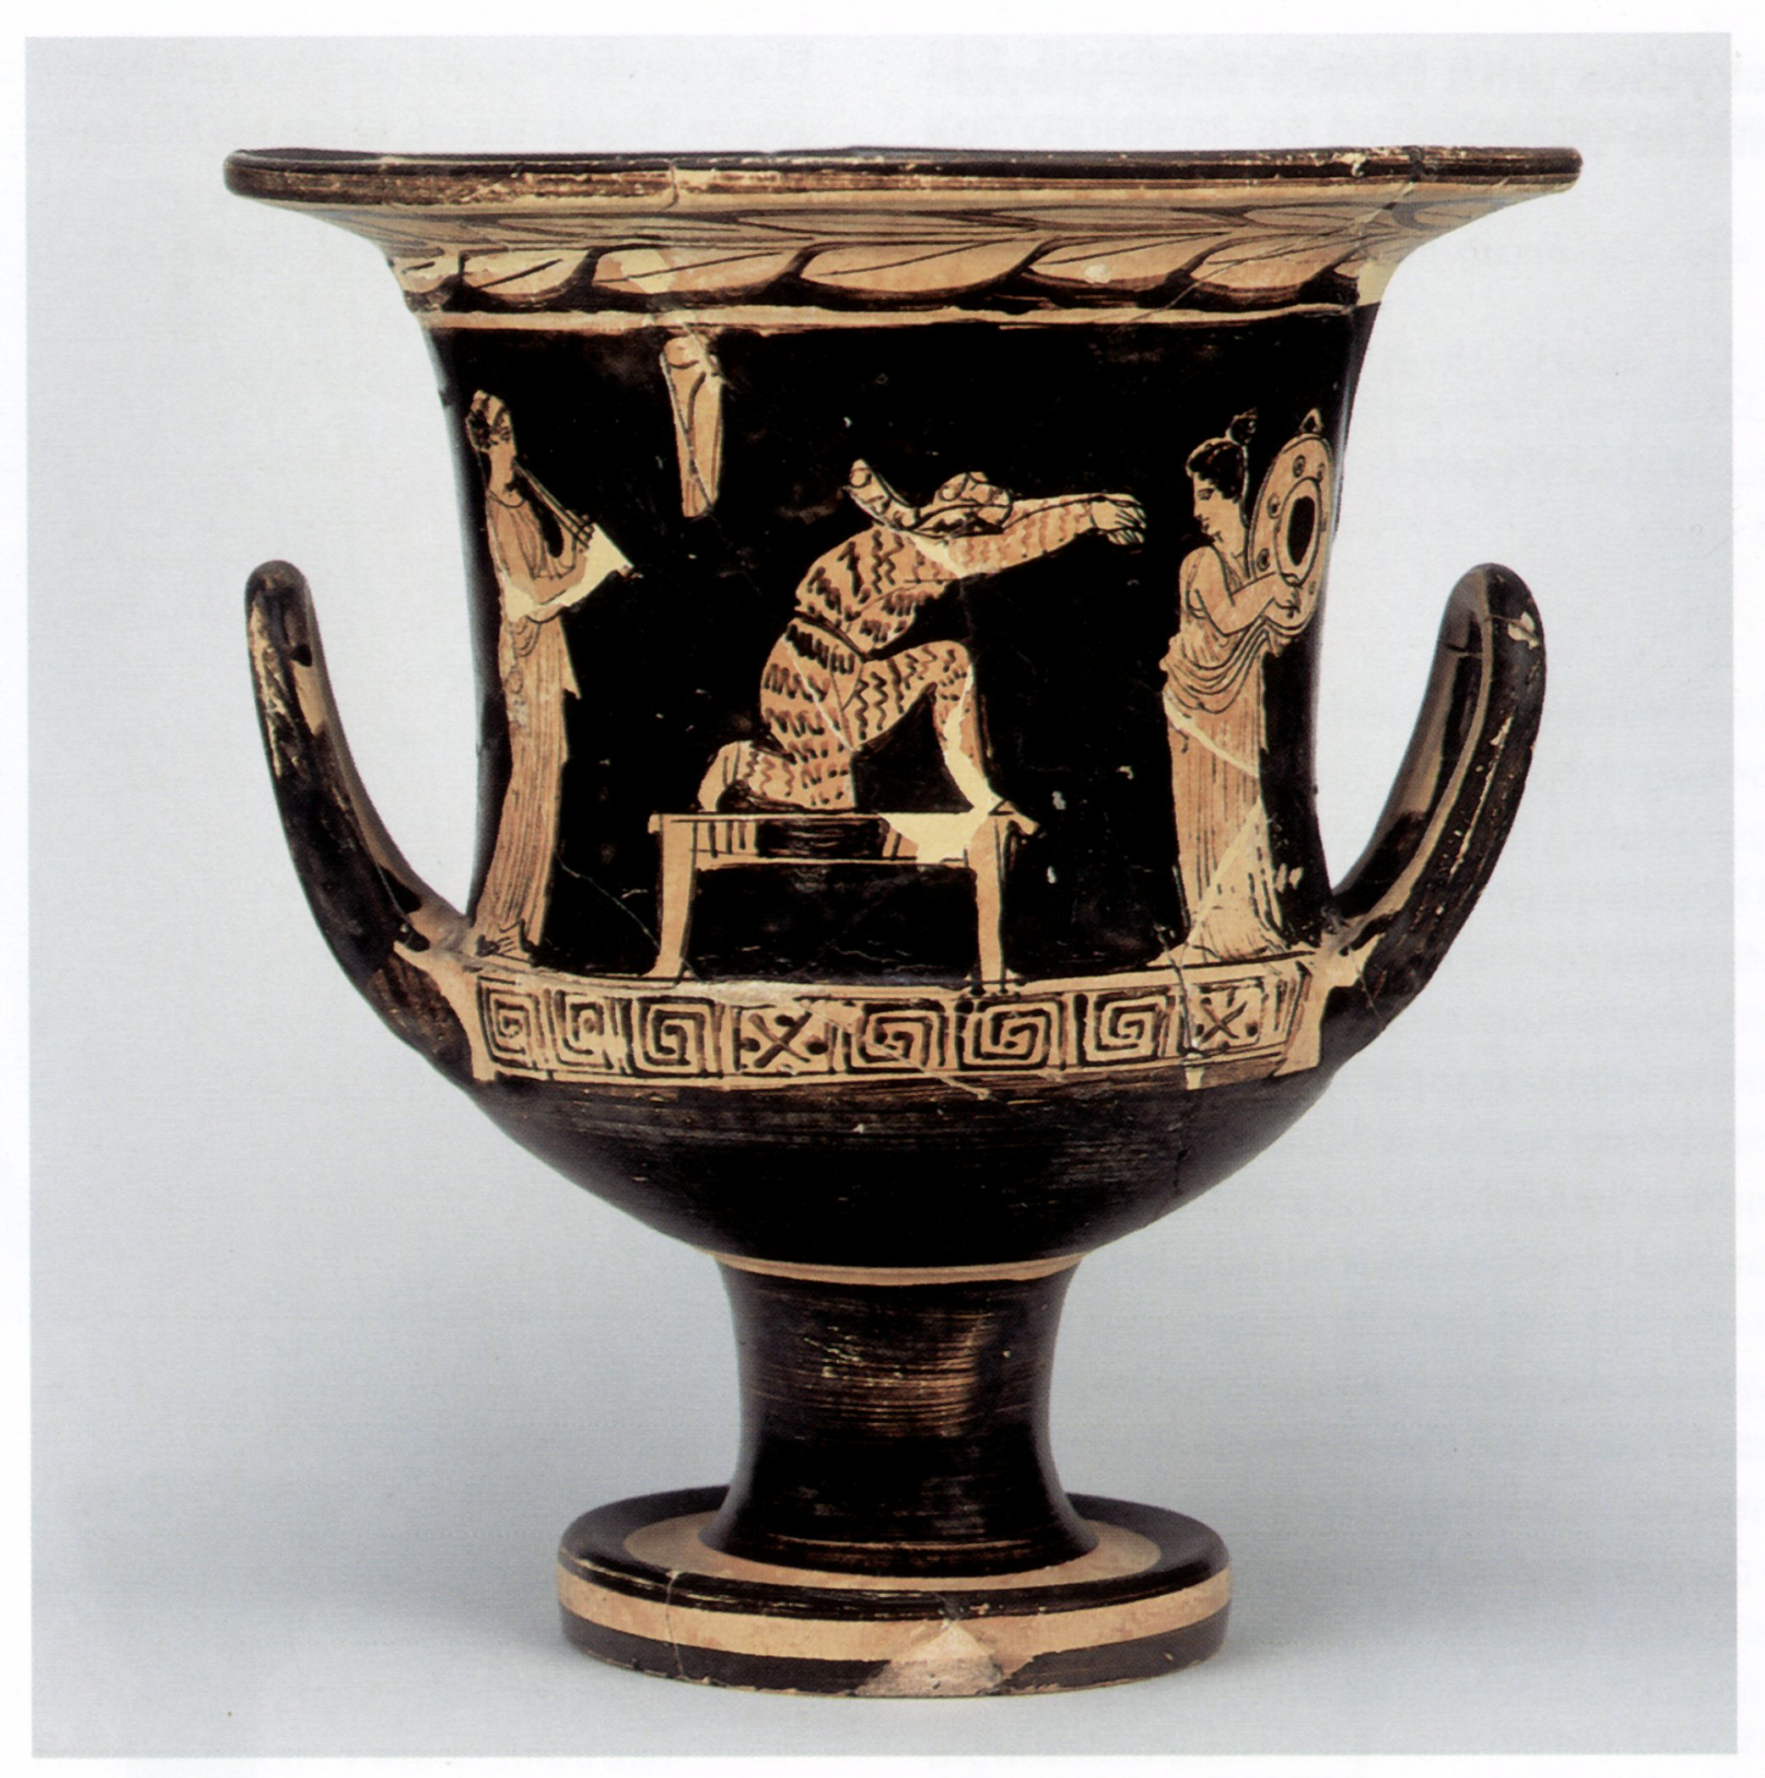
s4125
Votive relief stele to Apollo and Cybele
Sculpture, relief, marble
-120 (B.C. approximately)
80 x 39.5 cm
Greece, Athens, National Archaeological Museum, 1485
In the scene below a girl dances to the music of two aulos-players. On the right, slaves draw wine from vases for the drinking party (symposium) pictured above.
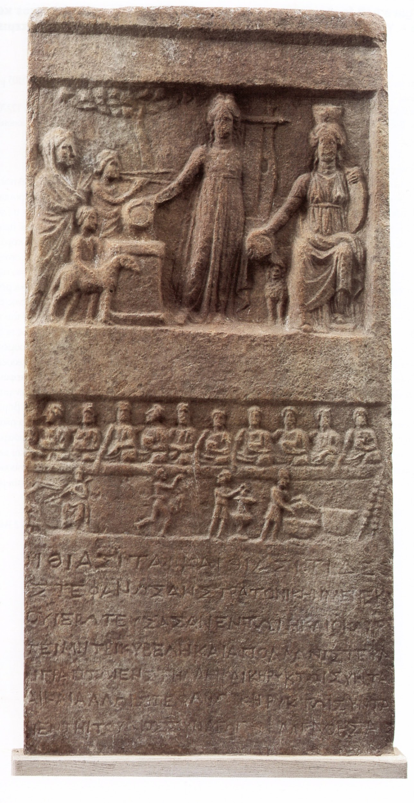

s4123
Grave stele of a female dancer holding clappers and a boy
Sculpture, relief, Pentelic white marble
-350 (B.C. approximately)
77 x 12 cm
Greece, Athens, National Archaeological Museum, 1896
The boy is probably the son of the dead dancer, a rare example of the occuation of the deceased.
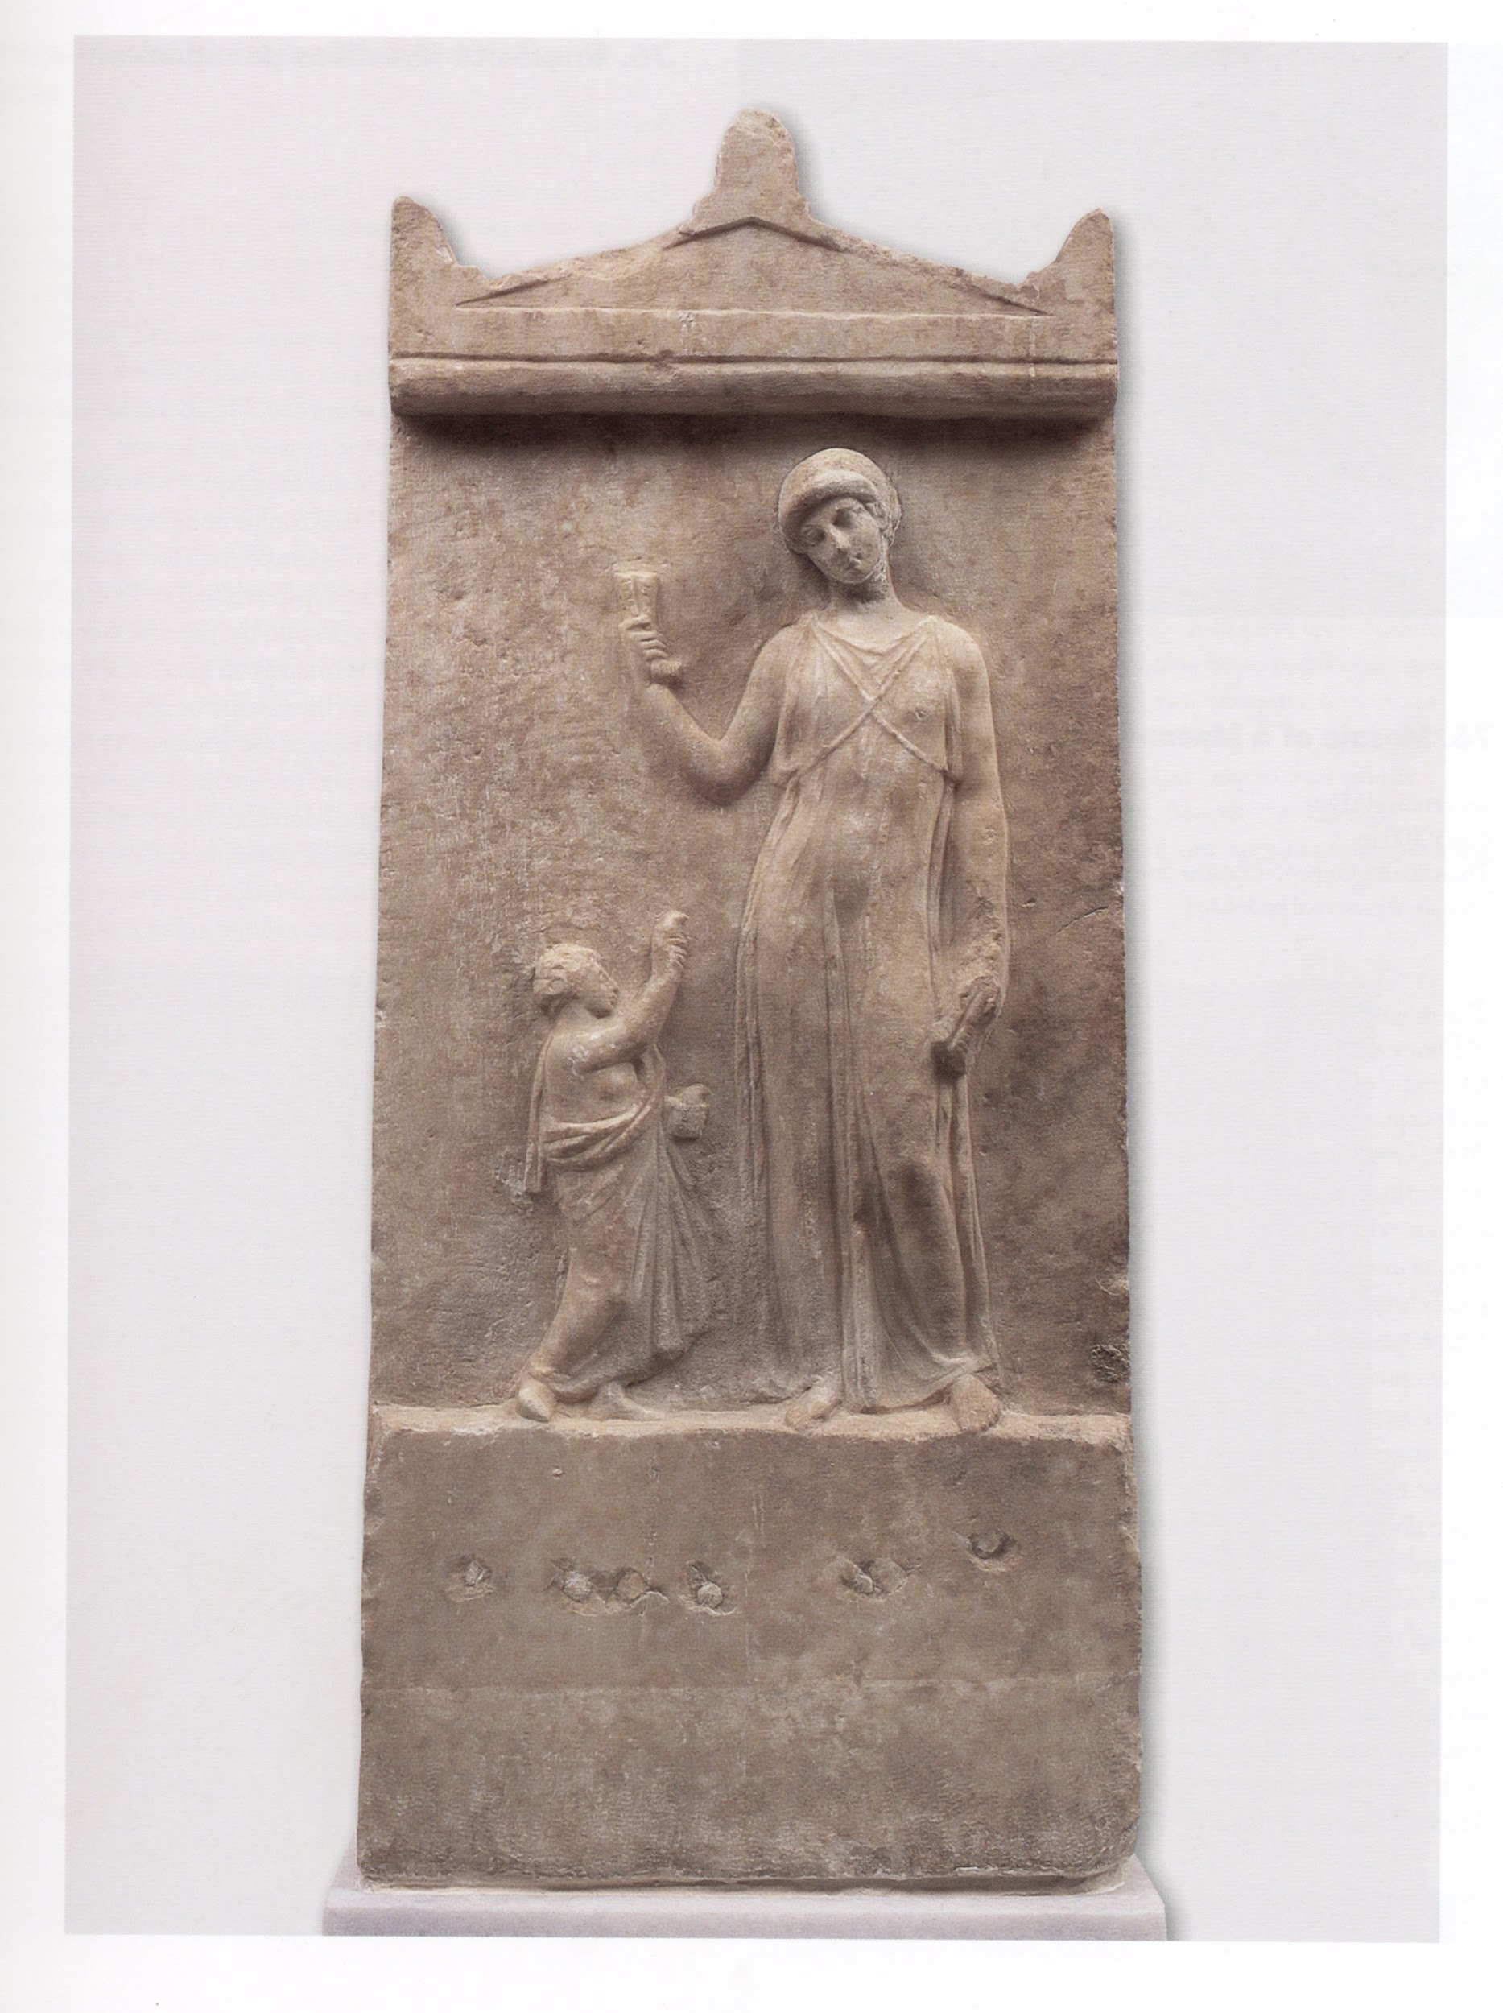
s4146
Figurine of a dancing (?) girl with tambourine
Sculpture, clay statuette, terracotta
-350 (B.C. approximately)
25 cm height
Greece, Athens, National Archaeological Museum, 4550
Found at Tanagra, the product of a Boeotian workshop
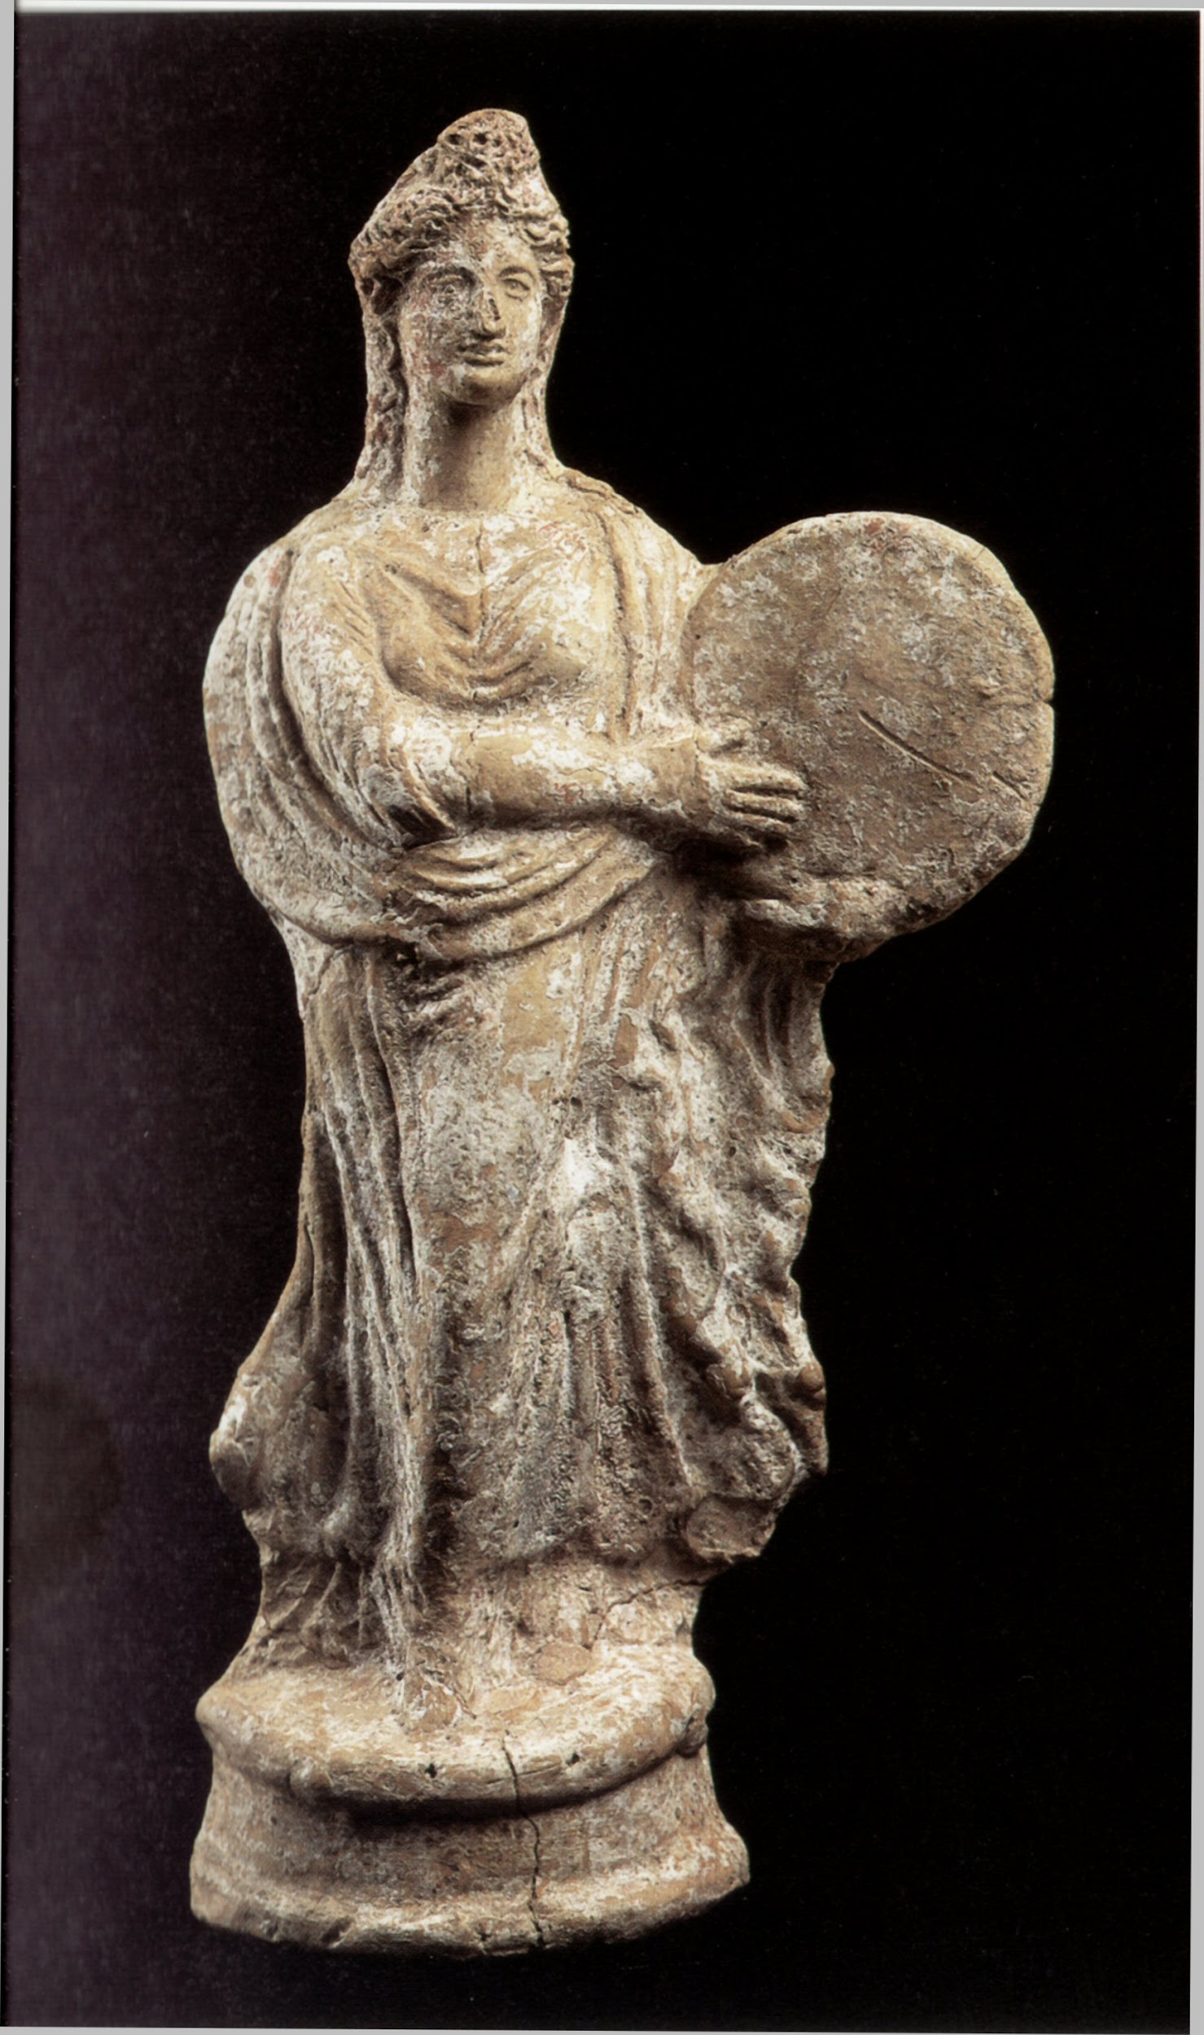
s4149
Figurine of a dancing girl, face covered by her Himation garment
Sculpture, clay statuette, terracotta
-350 (B.C. approximately)
25 cm height
Greece, Athens, National Archaeological Museum, 4577
Found at Tanagra, the product of a Boeotian workshop
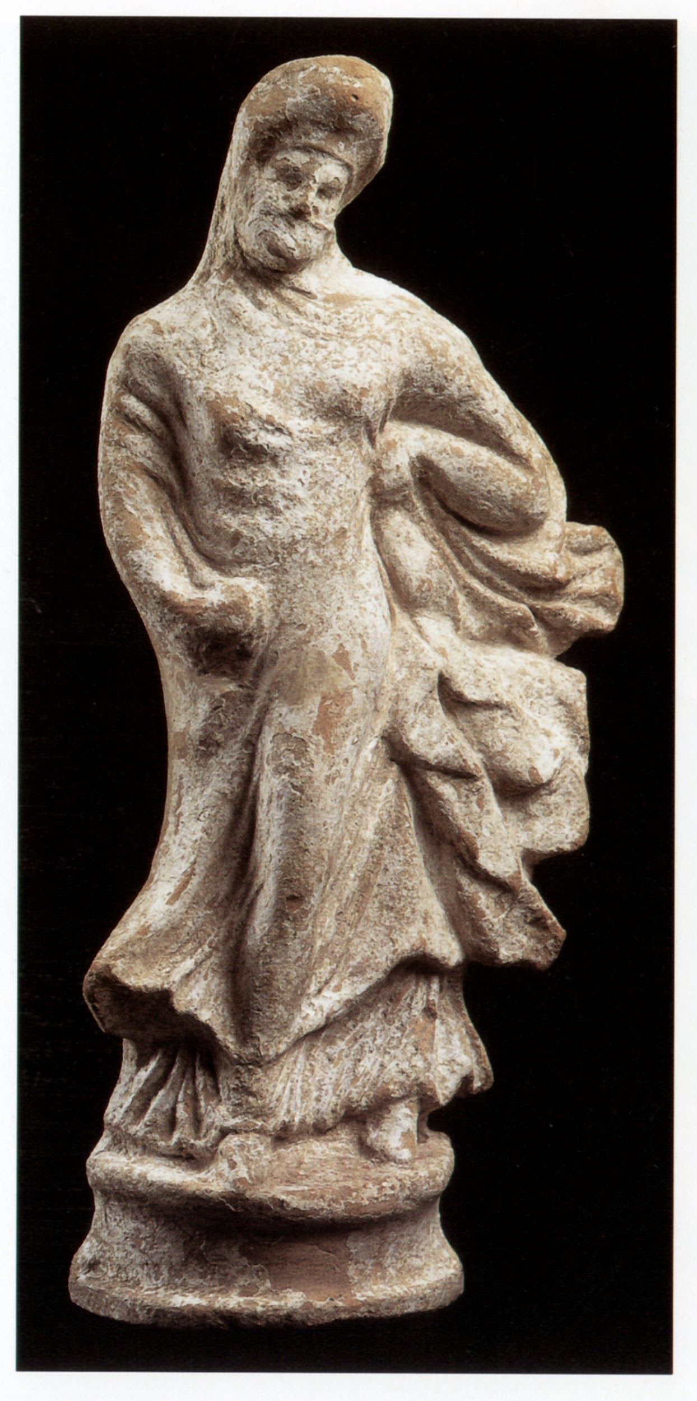
s4151
Figurine of a dancing girl leaning her covered head backwards
Sculpture, clay statuette, terracotta
-350 (B.C. approximately)
19.5 cm height
Greece, Athens, National Archaeological Museum, 5767
Product of a Boeotian workshop. The dancer wears a Himation garment
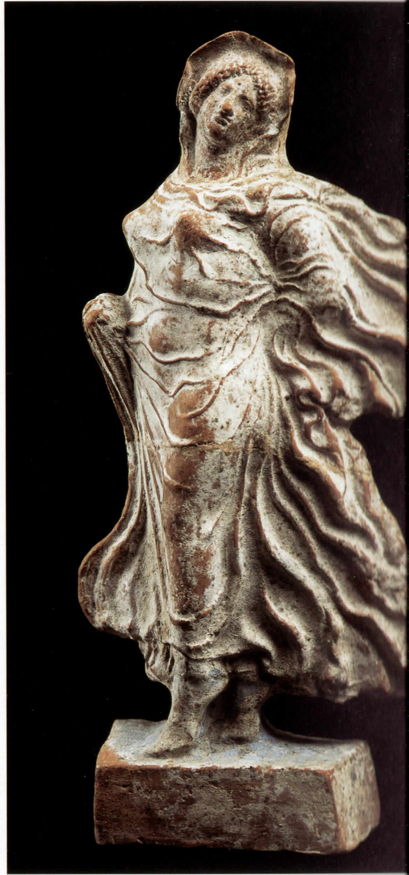

p3657
Boy leading girls to dance
Sculpture, relief on marble
-350 (B.C. approximately)
Greece, Athens, National Archeological Museum
Votive offering
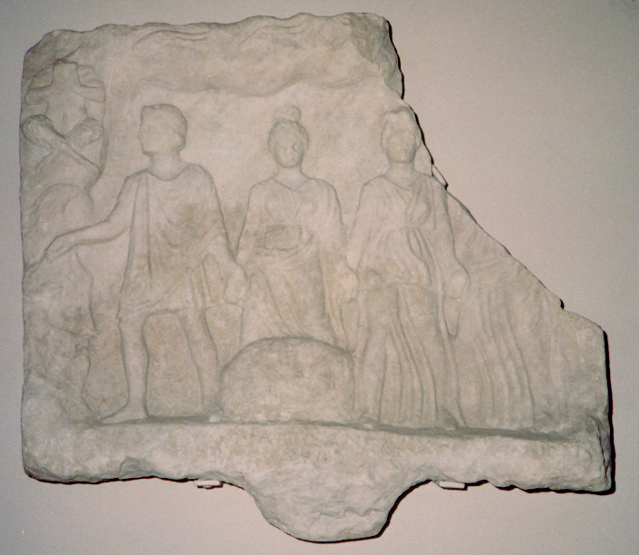

p3860
Votive plaque
Sculpture, relief, marble
-400 (B.C. approximately)
Greece, Athens, National Archeological Museum
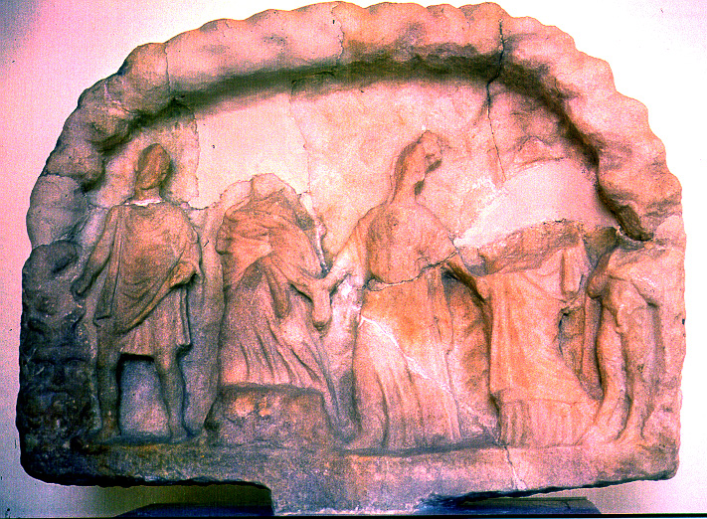

p3659
Young man leading three young women to dance
Sculpture, relief on marble
-350 (B.C. approximately)
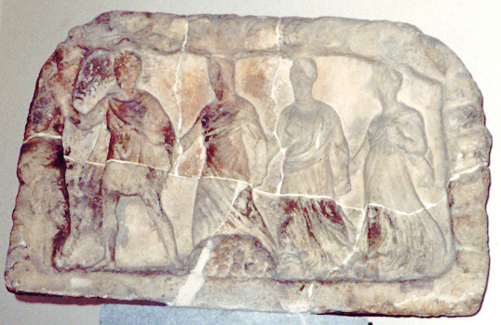

p3656
Seated flutist and three women dancing
Sculpture, relief on marble
-350 (B.C. approximately)
Greece, Athens, National Archeological Museum
Votive offering
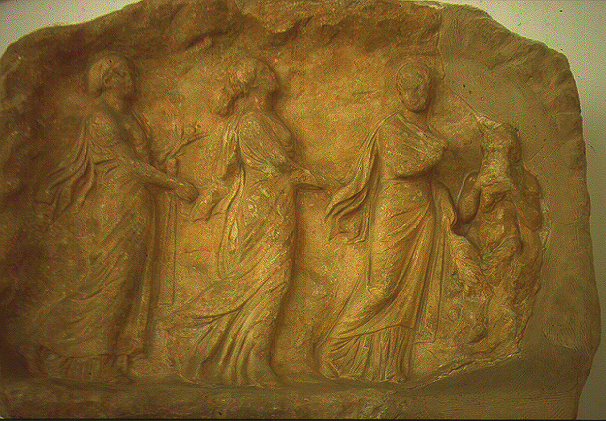

p3658
Flutist marching before three dancing women
Sculpture, relief on marble
-320 (B.C. approximately)
Greece, Athens, National Archeological Museum, 1445
Votive offering
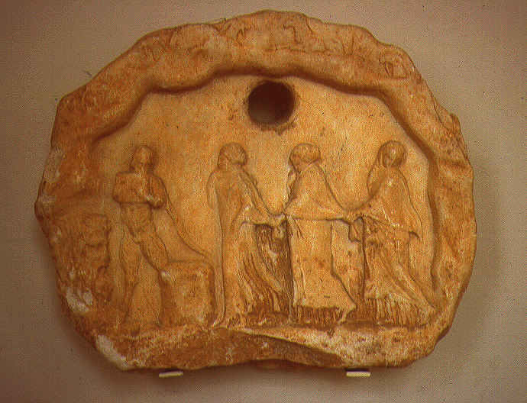

p0470
Dancer holding her head-scarf
Sculpture, relief, Pentelic white marble
-30 (B.C. approximately)
124 x 64 x 14.5 cm
Greece, Athens, National Archeological Museum, 260
Neo-attic art, after an original of the second half of the 4th century BC. Probaly one of the Hours or a Nymph, both daughters of Zeus. Found in Athens, in the Theater of Dionysos
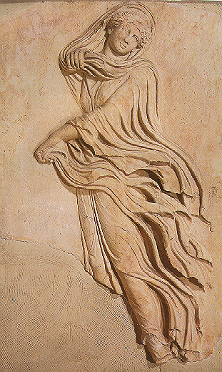

s4346
One of the Nymphs or Charites dancing on a marble crater
Sculpture
-35 (B.C. approximately)

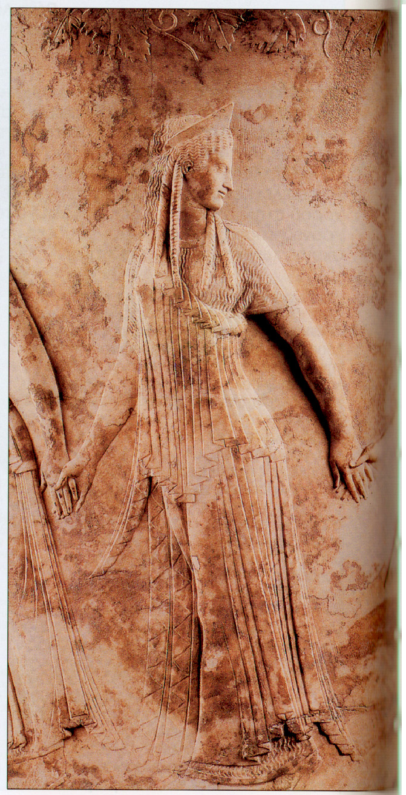

Flutist marching before three dancing women
Relief on marble
320 B.C., approximately
Votive offering
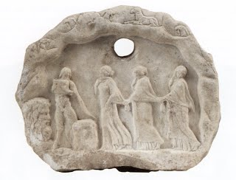
p3964
Female dancer (?)
Sculpture, relief, seal
-1500 (B.C. approximately)
2 cm diameter
Greece, Athens, National Archeological Museum
Seal found in Vaphio. Minoan or Mycenean art
